“Functional Models: Workflow Sentinel –Python-Based Automation Governance and Risk Analyzer”
Manideep Gujju, Systems Analyst
February 10, 2026

- Use Case Diagram
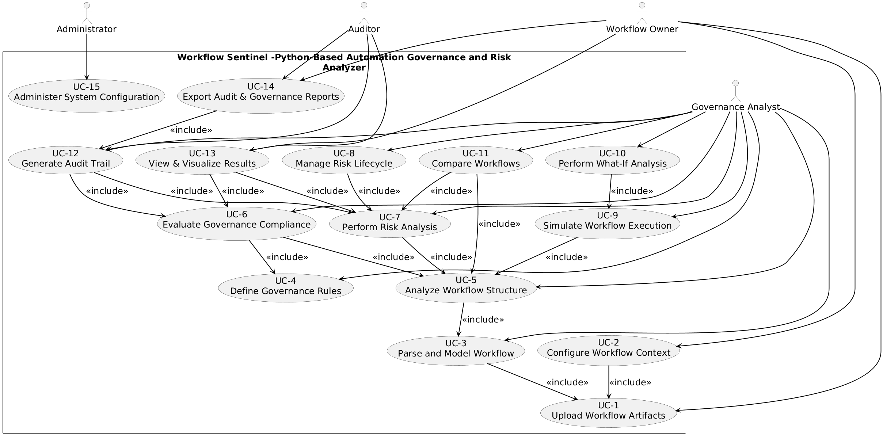
Diagram 1: Use Case Diagram for “Workflow Sentinel –Python-Based Automation Governance and Risk Analyzer”
- Use Case Description
Use Case - 1
Use Case Name: Upload Workflow Artifacts |  | ID:UC1 | Importance Level: High
Primary Actor: Workflow Owner | Use Case Type: Essential
Stakeholders and Interests: The Workflow Owner wants to submit exported Power Automate workflow artifacts so they can be analyzed for governance, risk, and compliance. Governance Analysts and Auditors have an interest in ensuring that the uploaded artifacts are complete, valid, and preserved without modification so that subsequent analysis and audit activities are accurate and reliable.
Brief Description: This use case describes how a Workflow Owner uploads one or more exported Power Automate workflow artifacts into the system so that they can be stored and prepared for analysis.
Trigger: The Workflow Owner decides to submit workflow artifacts for governance and risk analysis.
Type: External
Relationships:
Association: Workflow Owner
Include: None
Extend: None
Generalization: None
Normal Flow of Events:
- The Workflow Owner selects the option to upload workflow artifacts.
- The system prompts the Workflow Owner to select one or more workflow files.
- The Workflow Owner submits exported workflow artifacts in JSON or XML format.
- The system validates that the selected files conform to supported formats.
- The system stores the uploaded workflow artifacts without modifying their contents.
- The system confirms that the workflow artifacts are successfully uploaded and available for further processing.
SubFlows:
- S-1: If multiple workflow artifacts are uploaded, the system groups them into a single analysis set.
Alternate/Exceptional Flows:
A-1: If a selected file is not in a supported format, the system rejects the file and notifies the Workflow Owner.
A-2: If a selected file is incomplete or corrupted, the system reports the error and prevents the upload.

This use case description is covering the requirements – FR-1, FR-2

Use Case - 2
Use Case Name: Configure Workflow Context |  | ID:UC-2 | Importance Level: High
Primary Actor: Workflow Owner | Use Case Type: Essential
Stakeholders and Interests: The Workflow Owner wants to assign ownership, accountability metadata, and execution assumptions to each workflow and workflow step to ensure accurate governance and risk analysis. Governance Analysts and Auditors rely on this context to correctly interpret workflow execution, enforce rules, and generate meaningful reports.
Brief Description: This use case describes how a Workflow Owner configures workflow context for uploaded workflow artifacts, including ownership, step classification, execution assumptions, and versioning, so that downstream analysis is accurate and auditable.
Trigger: The Workflow Owner has uploaded workflow artifacts (UC-01) and wants to set context for analysis.
Type: External
Relationships:
Association: Workflow Owner
Include: UC-01 – Upload Workflow Artifacts
Extend: None
Generalization: None
Normal Flow of Events:
- The Workflow Owner selects a workflow artifact from the uploaded set.
- The system displays existing metadata and execution context (if any).
- The Workflow Owner assigns ownership and accountability to the workflow and each workflow step.
- The Workflow Owner defines execution assumptions such as start time, triggers, and frequency.
- The Workflow Owner classifies workflow steps by business purpose (e.g., notification, approval, data transfer).
- The system saves the workflow context and confirms successful configuration.
SubFlows:
- S-1: If multiple workflows are selected, the system allows context to be applied individually or in bulk.
Alternate/Exceptional Flows:
A-1: If metadata conflicts with previous configuration, the system alerts the Workflow Owner and requests resolution.
A-2: If execution assumptions are invalid (e.g., trigger time in the past), the system rejects the input and prompts correction.

This use case description is covering the requirements – FR-2, FR-3, FR-4, FR-5
Use Case - 3
Use Case Name: Parse and Model Workflow |  | ID:UC-3 | Importance Level: High
Primary Actor: Governance Analyst | Use Case Type: Essential
Stakeholders and Interests:
The Governance Analyst needs to parse uploaded workflow artifacts and model them as graph structures to detect dependencies, parallelism, and potential conflicts. Workflow Owners rely on accurate parsing for subsequent context configuration (UC-02), and Auditors depend on correct models for risk assessment and compliance verification.
Brief Description: This use case describes how the Governance Analyst parses uploaded workflow artifacts and constructs graph-based models of workflows so that dependencies, execution paths, and conflicts can be analyzed accurately.
Trigger: The Governance Analyst selects workflow artifacts that have been uploaded and configured for context (UC-01, UC-02) and requests parsing and modeling.
Type: External
Relationships:
Association: Governance Analyst
Include: UC-01 – Upload Workflow Artifacts
Extend: None
Generalization: None
Normal Flow of Events:
- The Governance Analyst selects workflow artifacts for parsing.
- The system reads JSON/XML workflow files and validates them.
- The system constructs graph models representing workflow steps and dependencies.
- The system identifies sequential, parallel, and conditional execution paths.
- The system stores the workflow models for downstream analysis and displays a summary of parsing results.
SubFlows:
S-1: If multiple workflows are selected, each is parsed individually, and combined models are created for set-level analysis.
Alternate/Exceptional Flows:
A-1: If a workflow artifact is corrupted or invalid, the system logs the error and notifies the Governance Analyst.
A-2: If dependencies cannot be resolved due to missing steps, the system highlights unresolved nodes for manual review.

This use case description is covering the requirements – FR-6, FR-7

Use Case - 4
Use Case Name: Define Governance Rules |  | ID:UC-4 | Importance Level: High
Primary Actor: Governance Analyst | Use Case Type: Essential
Stakeholders and Interests: The Governance Analyst wants to define governance rules, thresholds, and templates to ensure workflow execution aligns with organizational policies. Workflow Owners depend on these rules to configure workflows correctly, and Auditors rely on consistent governance rules for compliance verification.
Brief Description: This use case describes how the Governance Analyst defines governance rules and thresholds that the system uses to evaluate workflow compliance, detect conflicts, and enforce policies.
Trigger: The Governance Analyst needs to set or update governance rules before analyzing workflows.
Type: External
Relationships:
Association: Governance Analyst
Include: None
Extend: None
Generalization: None
Normal Flow of Events:
- The Governance Analyst opens the governance rules configuration interface.
- The system displays existing rules, thresholds, and templates.
- The Governance Analyst defines new rules or modifies existing ones for workflow ownership, timing, resources, or compliance.
- The Governance Analyst defines thresholds to determine risk severity levels.
- The system saves and validates the new governance rules for use in workflow analysis.
SubFlows:
- S-1: The Governance Analyst can create rule templates for reuse across multiple workflows.
Alternate/Exceptional Flows:
A-1: If a rule conflicts with existing rules, the system alerts the Governance Analyst and requests resolution.
A-2: If thresholds are invalid or incomplete, the system rejects them and prompts correction.

This use case description is covering the requirements – FR-8, FR-9, FR-11, FR-12, FR-27, FR-28

Use Case - 5
Use Case Name: Analyze Workflow Structure |  | ID:UC-5 | Importance Level: High
Primary Actor: Governance Analyst | Use Case Type: Essential
Stakeholders and Interests: The Governance Analyst wants to evaluate workflow structures to identify execution paths, conflicts, unused steps, and resource usage. Workflow Owners depend on this analysis to understand workflow behavior and improve configurations, while Auditors rely on it to verify compliance and detect potential risks.
Brief Description: This use case describes how the Governance Analyst analyzes parsed workflow models to detect execution paths, conflicts, redundant or unused steps, and resource utilization to ensure workflows operate as intended and comply with governance rules.
Trigger: The Governance Analyst initiates workflow structure analysis after parsing and modeling the workflow (UC-03).
Type: External
Relationships:
Association: Governance Analyst
Include: UC-03 – Parse and Model Workflow
Extend: None
Generalization: None
Normal Flow of Events:
- The Governance Analyst selects a workflow or workflow set to analyze.
- The system retrieves the parsed workflow models.
- The system identifies sequential, parallel, and conditional execution paths.
- The system detects potential conflicts between steps based on governance rules.
- The system highlights unused, unreachable, or redundant steps.
- The system evaluates resource usage assumptions, such as concurrency and execution frequency.
- The system presents a structured analysis summary for review.
SubFlows:
S-1: If multiple workflows are analyzed together, the system identifies shared steps and resources.
Alternate/Exceptional Flows:
A-1: If the workflow model contains unresolved dependencies, the system flags them for manual inspection.
A-2: If resource usage assumptions are inconsistent or incomplete, the system alerts the Governance Analyst.

This use case description is covering the requirements – FR-7, FR-10, FR-14, FR-15, FR-16, FR-17

Use Case - 6
Use Case Name: Evaluate Governance Compliance |  | ID:UC-6 | Importance Level: High
Primary Actor: Governance Analyst | Use Case Type: Essential
Stakeholders and Interests: The Governance Analyst needs to check workflows against governance policies to ensure compliance with organizational rules. Workflow Owners rely on compliance evaluation to correct workflow configurations, and Auditors depend on consistent compliance assessment for reporting and accountability.
Brief Description: This use case describes how the Governance Analyst evaluates workflows for compliance with governance rules, analyzes execution intent, and ensures that workflow actions conform to organizational policies before approval or execution.
Trigger: The Governance Analyst initiates compliance evaluation after analyzing workflow structure (UC-05) and defining governance rules (UC-04).
Type: External
Relationships:
Association: Governance Analyst
Include: UC-04 – Define Governance Rules, UC-05 – Analyze Workflow Structure
Extend: None
Generalization: None
Normal Flow of Events:
- The Governance Analyst selects a workflow or workflow set for compliance evaluation.
- The system retrieves the workflow model and the applicable governance rules.
- The system checks execution intent and workflow steps against governance policies.
- The system identifies violations of timing, ownership, or resource usage rules.
- The system calculates compliance status and prepares a summary report.
SubFlows:
S-1: If multiple workflows are evaluated, the system aggregates compliance results for comparison.
Alternate/Exceptional Flows:
A-1: If a rule cannot be applied due to missing context or metadata, the system flags the workflow for manual review.

A-2: If violations exceed acceptable thresholds, the system alerts the Governance Analyst and recommends corrective actions.

This use case description is covering the requirements – FR-12, FR-20

Use Case - 7
Use Case Name: Perform Risk Analysis |  | ID:UC-7 | Importance Level: High
Primary Actor: Governance Analyst | Use Case Type: Essential
Stakeholders and Interests: The Governance Analyst needs to calculate risk scores and analyze risk propagation for workflows to identify critical issues. Workflow Owners rely on risk results to improve workflow configurations, and Auditors depend on risk analysis for accountability, audit trails, and compliance verification.
Brief Description: This use case describes how the Governance Analyst performs risk analysis on workflows to generate risk scores, assess severity, and identify how risks propagate across workflow steps for informed decision-making.
Trigger: The Governance Analyst initiates risk analysis after evaluating workflow structure (UC-05) and governance compliance (UC-06).
Type: External
Relationships:
Association: Governance Analyst
Include: UC-05 – Analyze Workflow Structure
Extend: None
Generalization: None
Normal Flow of Events:
- The Governance Analyst selects a workflow or workflow set for risk analysis.
- The system retrieves workflow models, governance rules, and compliance results.
- The system calculates risk scores based on rule violations, dependencies, and execution assumptions.
- The system identifies risk propagation across dependent workflow steps.
- The system classifies risks by severity and generates a summary report.
SubFlows:
S-1: If multiple workflows are analyzed together, the system identifies shared risks and cumulative severity.
Alternate/Exceptional Flows:
A-1: If a workflow step cannot be assessed due to missing metadata, the system flags it as unresolved risk.
A-2: If risk calculation fails due to invalid assumptions, the system notifies the Governance Analyst and requests correction.

This use case description is covering the requirements – FR-13, FR-14

Use Case - 8
Use Case Name: Manage Risk Lifecycle |  | ID:UC-8 | Importance Level: High
Primary Actor: Governance Analyst | Use Case Type: Essential
Stakeholders and Interests: The Governance Analyst needs to manage identified workflow risks by accepting, mitigating, or documenting them to ensure informed decision-making. Workflow Owners rely on these actions to adjust workflows and reduce operational risk, and Auditors depend on risk lifecycle records for compliance verification and accountability.
Brief Description: This use case describes how the Governance Analyst reviews identified workflow risks, applies mitigation actions, documents resolutions, and updates risk records for traceability and governance.
Trigger: The Governance Analyst initiates risk lifecycle management after performing risk analysis (UC-07).
Type: External
Relationships:
Association: Governance Analyst
Include: UC-07 – Perform Risk Analysis
Extend: None
Generalization: None
Normal Flow of Events:
- The Governance Analyst reviews the list of identified workflow risks.
- The system displays risk severity, propagation paths, and affected workflow steps.
- The Governance Analyst accepts, mitigates, or flags unresolved risks.
- The system records all decisions and updates the risk database.
- The Governance Analyst documents recommended mitigation actions for each risk.
SubFlows:
S-1: The Governance Analyst can rerun analysis after mitigation actions to verify risk reduction.
Alternate/Exceptional Flows:
A-1: If a risk cannot be mitigated due to workflow constraints, the system flags it for escalation.
A-2: If documentation is incomplete, the system requests additional details before closing the risk.

This use case description is covering the requirements – FR-35, FR-36, FR-37

Use Case - 9
Use Case Name: Simulate Workflow Execution |  | ID:UC-9 | Importance Level: High
Primary Actor: Governance Analyst | Use Case Type: Essential
Stakeholders and Interests: The Governance Analyst wants to simulate workflow execution to evaluate execution order, state transitions, and potential conflicts before actual deployment. Workflow Owners rely on simulation results to optimize workflows, and Auditors depend on simulations to verify governance compliance and accountability.
Brief Description: This use case describes how the Governance Analyst initiates offline simulation of workflows to evaluate execution sequences, identify conflicts, and verify compliance with governance rules.
Trigger: The Governance Analyst initiates simulation after analyzing workflow structure (UC-05) and managing governance rules (UC-04).
Type: External
Relationships:
Association: Governance Analyst
Include: UC-05 – Analyze Workflow Structure
Extend: None
Generalization: None
Normal Flow of Events:
- The Governance Analyst selects a workflow or workflow set to simulate.
- The system retrieves parsed workflow models and applied governance rules.
- The system simulates execution order and state transitions step by step.
- The system identifies potential conflicts, bottlenecks, or rule violations.
- The system presents a summary of simulation results and highlights areas requiring attention.
SubFlows:
S-1: The Governance Analyst can adjust workflow assumptions (triggers, timing) to test alternative execution sequences.
Alternate/Exceptional Flows:
A-1: If the workflow contains unresolved dependencies, the system flags steps and stops simulation.
A-2: If the simulation encounters conflicting rules that prevent execution, the system notifies the Governance Analyst.

This use case description is covering the requirements – FR-10

Use Case - 10
Use Case Name: Perform What-If Analysis |  | ID:UC-10 | Importance Level: High
Primary Actor: Governance Analyst | Use Case Type: Essential
Stakeholders and Interests: The Governance Analyst wants to test alternative workflow execution scenarios to identify potential improvements, reduce risks, and validate governance compliance. Workflow Owners rely on these simulations to optimize workflow designs, and Auditors benefit from traceable scenario evaluations for accountability and compliance.
Brief Description: This use case describes how the Governance Analyst simulates alternative workflow scenarios by modifying triggers, conditions, or dependencies to evaluate potential outcomes, risks, and governance compliance.
Trigger: The Governance Analyst initiates what-if analysis after simulating workflow execution (UC-09).
Type: External
Relationships:
Association: Governance Analyst
Include: UC-09 – Simulate Workflow Execution
Extend: None
Generalization: None
Normal Flow of Events:
- The Governance Analyst selects a workflow or workflow set for scenario analysis.
- The system retrieves the workflow model, governance rules, and prior simulation results.
- The Governance Analyst modifies execution assumptions, triggers, or dependencies.
- The system simulates the modified scenarios and evaluates workflow outcomes.
- The system presents risk, compliance, and performance comparisons for each scenario.
SubFlows:
S-1: The Governance Analyst can compare results of multiple scenarios to identify optimal configurations.
Alternate/Exceptional Flows:
A-1: If modified assumptions violate governance rules, the system alerts the Governance Analyst.
A-2: If simulation cannot complete due to conflicting dependencies, the system flags the issue for resolution.

This use case description is covering the requirements – FR-11, FR-37

Use Case - 11
Use Case Name: Compare Workflows |  | ID:UC-11 | Importance Level: High
Primary Actor: Governance Analyst | Use Case Type: Essential
Stakeholders and Interests: The Governance Analyst needs to compare multiple workflows or workflow versions to identify shared steps, resources, or risks. Workflow Owners rely on this comparison to optimize workflows and prevent duplication or conflicts, and Auditors depend on it to verify consistency and compliance across workflow versions.
Brief Description: This use case describes how the Governance Analyst evaluates two or more workflows to identify similarities, differences, shared resources, and potential conflicts to improve workflow efficiency and reduce risk.
Trigger: The Governance Analyst initiates workflow comparison after performing structure analysis (UC-05) and risk analysis (UC-07).
Type: External
Relationships:
Association: Governance Analyst
Include: UC-05 – Analyze Workflow Structure
Extend: None
Generalization: None
Normal Flow of Events:
- The Governance Analyst selects multiple workflows or versions to compare.
- The system retrieves the workflow models and prior analysis results.
- The system identifies shared steps, shared resources, and dependencies.
- The system highlights differences, potential conflicts, and risk overlaps.
- The system generates a comparison summary report for review.
SubFlows:
S-1: The Governance Analyst can focus comparison on specific workflow steps or functional areas.
Alternate/Exceptional Flows:
- A-1: If workflows are incompatible due to missing metadata, the system flags the issue for resolution.
- A-2: If workflow versions are inconsistent, the system notifies the Governance Analyst to reconcile differences.

This use case description is covering the requirements – FR-19, FR-34

Use Case – 12
Use Case Name: Generate Audit Trail |  | ID:UC-12 | Importance Level: High
Primary Actor: Governance Analyst | Use Case Type: Essential
Stakeholders and Interests: The Governance Analyst needs to produce detailed, explainable audit trails documenting workflow decisions, risks, and compliance checks. Workflow Owners rely on these trails for accountability and reporting, while Auditors depend on them to verify governance consistency, historical analyses, and compliance with organizational policies.
Brief Description: This use case describes how the Governance Analyst generates audit trails capturing workflow decisions, risk assessments, compliance evaluations, and analysis history for accountability and reporting purposes.
Trigger: The Governance Analyst initiates audit trail generation after performing compliance evaluation (UC-06) and risk analysis (UC-07).
Type: External
Relationships:
Association: Governance Analyst
Include: UC-06 – Evaluate Governance Compliance, UC-07 – Perform Risk Analysis
Extend: None
Generalization: None
Normal Flow of Events:
- The Governance Analyst selects a workflow or workflow set for audit trail generation.
- The system retrieves compliance, risk, and analysis results for the selected workflows.
- The system documents workflow decisions, rule evaluations, risk scores, and mitigation actions.
- The system stores a historical record of the analysis run for future reference.
- The system presents a summary of audit trail details and allows export for reporting purposes.
SubFlows:
S-1: The Governance Analyst can generate audit trails for multiple workflow versions for comparison.
Alternate/Exceptional Flows:
A-1: If analysis data is incomplete, the system flags missing information for the Governance Analyst.
A-2: If the workflow contains unresolved risks, the audit trail marks them as pending action.

This use case description is covering the requirements – FR-18, FR-22, FR-23, FR-38

Use Case - 13
Use Case Name: View & Visualize Results |  | ID:UC-13 | Importance Level: High
Primary Actor: Workflow Owner | Use Case Type: Essential
Stakeholders and Interests: The Workflow Owner needs to view workflow analysis results through dashboards, drill-downs, and visualizations to understand risks, conflicts, and governance findings. Governance Analysts rely on visualization to communicate complex analysis outcomes, and Auditors benefit from visual dashboards to quickly verify compliance and decision traces.
Brief Description: This use case describes how the Workflow Owner interacts with the system to view visual representations of workflow paths, risk levels, conflict points, and governance compliance.
Trigger: The Workflow Owner initiates result visualization after governance compliance evaluation (UC-06) and risk analysis (UC-07).
Type: External
Relationships:
Association: Workflow Owner
Include: UC-06 – Evaluate Governance Compliance, UC-07 – Perform Risk Analysis
Extend: None
Generalization: None
Normal Flow of Events:
- The Workflow Owner selects a workflow or workflow set to view.
- The system retrieves workflow analysis results, risk scores, and governance evaluations.
- The system displays interactive dashboards with workflow paths, risk propagation, and conflict points.
- The Workflow Owner drills down into individual workflow steps to examine associated risks and governance findings.
- The system updates visualizations based on user interactions, filtering, or selection criteria.
SubFlows:
S-1: The Workflow Owner can compare multiple workflows or workflow versions within the dashboards.
Alternate/Exceptional Flows:
A-1: If analysis results are incomplete, the system displays only available data and flags missing items.
A-2: If visualization fails due to unsupported workflow artifacts, the system notifies the Workflow Owner to review input files.

This use case description is covering the requirements – FR-31, FR-32

Use Case - 14
Use Case Name: Export Audit & Governance Reports |  | ID:UC-14 | Importance Level: High
Primary Actor: Workflow Owner | Use Case Type: Essential
Stakeholders and Interests: The Workflow Owner needs to export audit-ready and governance reports for portfolio, compliance, and presentation purposes. Governance Analysts rely on these exports to communicate findings, and Auditors depend on them to verify rule applications, risk assessments, and workflow accountability.
Brief Description: This use case describes how the Workflow Owner generates and exports detailed reports of workflow analysis results, risks, compliance status, and governance actions in a shareable format.
Trigger: The Workflow Owner initiates report export after generating dashboards or audit trails (UC-12, UC-13).
Type: External
Relationships:
Association: Workflow Owner
Include: UC-12 – Generate Audit Trail
Extend: None
Generalization: None
Normal Flow of Events:
- The Workflow Owner selects a workflow or workflow set for report generation.
- The system retrieves all relevant analysis results, audit trails, and governance findings.
- The system formats the data into an audit-ready report suitable for sharing or compliance submission.
- The Workflow Owner selects the export format (PDF, Excel, etc.) and destination.
- The system generates and stores the report, notifying the Workflow Owner of successful export.
SubFlows:
S-1: The Workflow Owner can export reports for multiple workflow versions to compare changes over time.
Alternate/Exceptional Flows:
A-1: If workflow analysis data is incomplete, the system flags missing sections in the report.
A-2: If export fails due to file format or storage issues, the system notifies the Workflow Owner and suggests alternatives.

This use case description is covering the requirements – FR-24, FR-33
Use Case - 15
Use Case Name: Administer System Configuration |  | ID:UC-15 | Importance Level: High
Primary Actor: Administrator | Use Case Type: Essential
Stakeholders and Interests: The Administrator needs to manage system roles, permissions, archives, and synthetic workflow generation. Workflow Owners, Governance Analysts, and Auditors rely on proper configuration to ensure secure, consistent, and accurate workflow analysis. The organization benefits from standardized governance policies and configurable system behavior.
Brief Description: This use case describes how the Administrator configures system roles, permissions, governance policies, and archival settings, and generates synthetic workflow artifacts for testing purposes.
Trigger: The Administrator initiates system configuration for user management, policy updates, or testing purposes.
Type: External
Relationships:
Association: Administrator
Include: None
Extend: None
Generalization: None
Normal Flow of Events:
- The Administrator logs into the system with administrative credentials.
- The Administrator defines or updates user roles and assigns permissions to Workflow Owners, Governance Analysts, and Auditors.
- The Administrator configures system-wide governance policies, thresholds, and templates.
- The Administrator archives or restores completed workflow analyses for long-term reference.
- The Administrator generates synthetic workflow artifacts for testing and validation.
SubFlows:
S-1: The Administrator can create templates for governance rules to ensure consistency.
S-2: The Administrator can modify assumptions used in workflow simulations globally.
Alternate/Exceptional Flows:
A-1: If the Administrator attempts unauthorized changes, the system blocks the action and logs the attempt.
A-2: If synthetic workflow generation fails due to invalid parameters, the system notifies the Administrator to correct inputs.

This use case description is covering the requirements – FR-25, FR-26, FR-29, FR-30, FR-39, FR-40

2. Activity Diagram
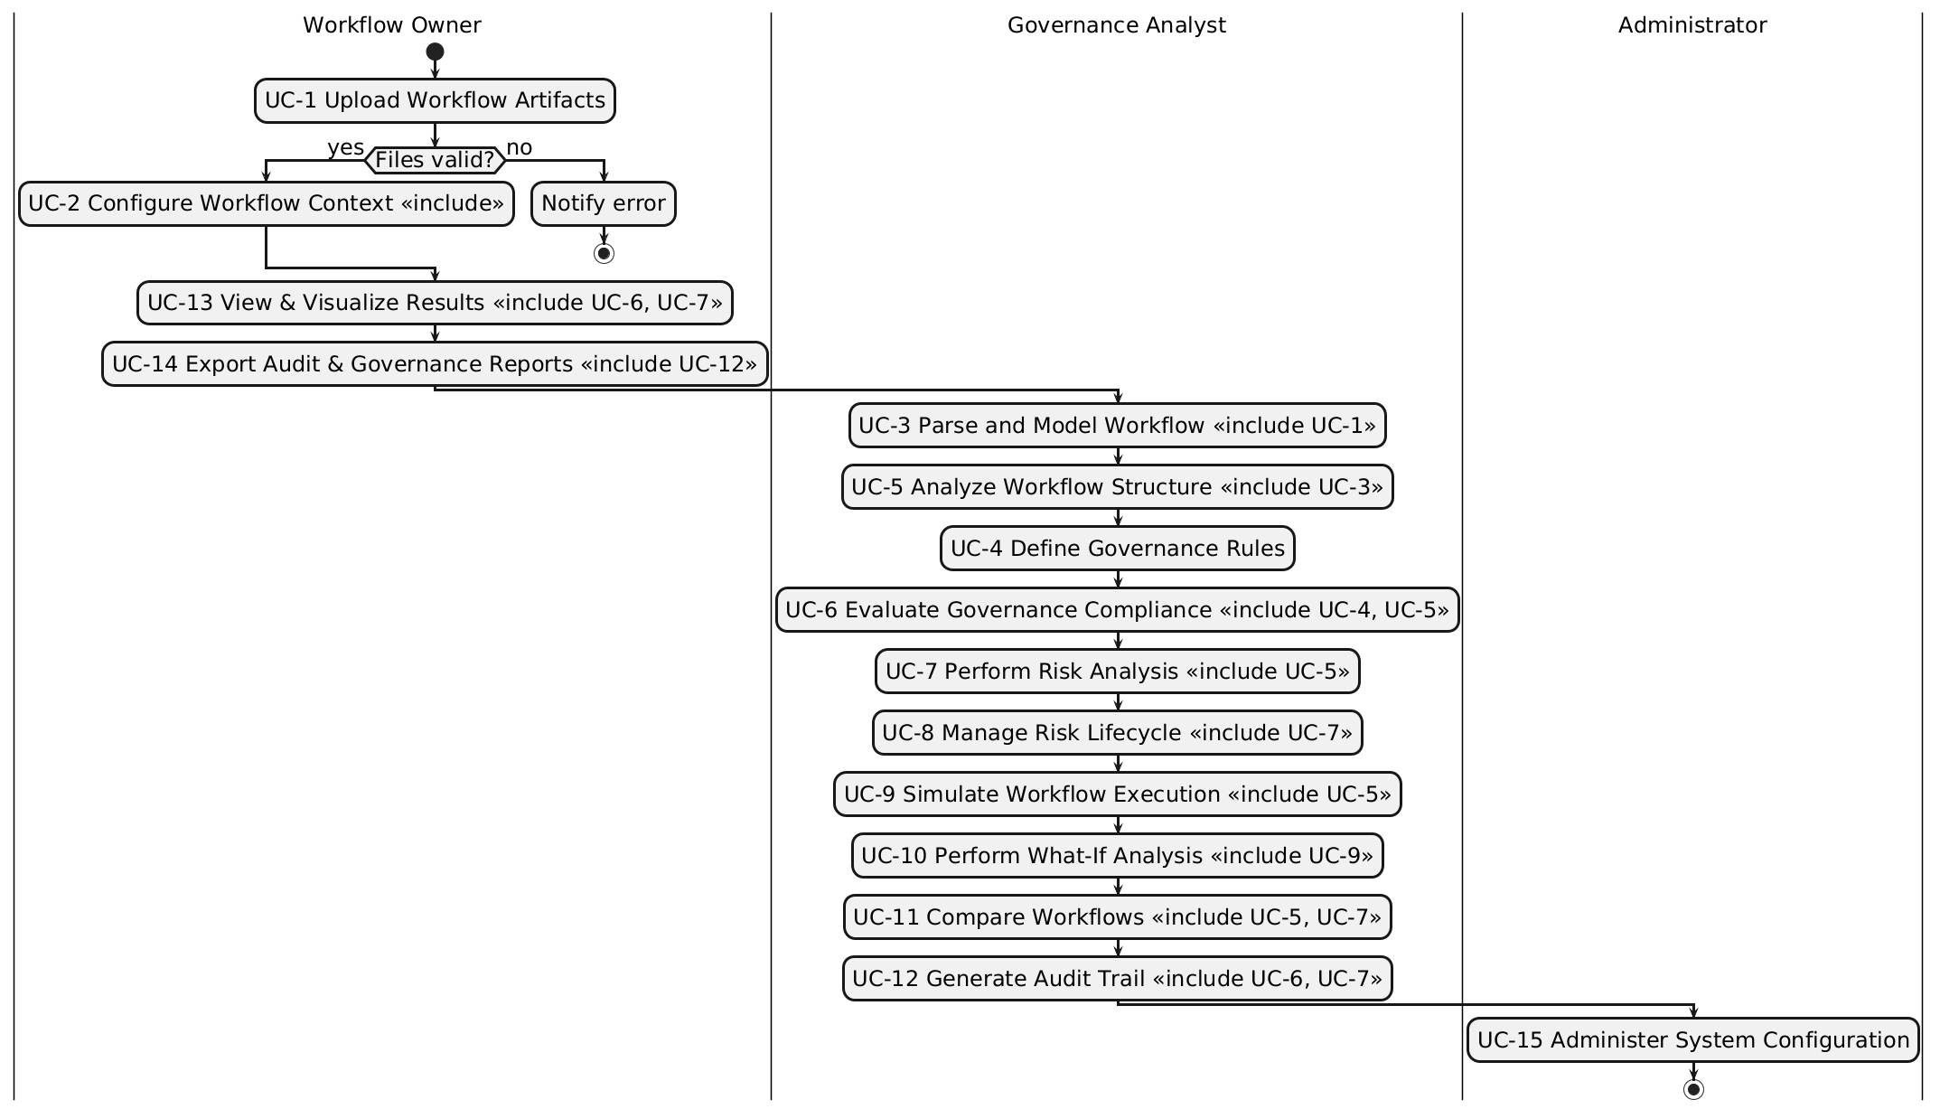
Diagram 2: Activity Diagram for “Workflow Sentinel –Python-Based Automation Governance and Risk Analyzer”

